
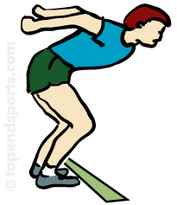


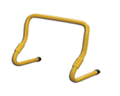

STATION 3: JUMPING
Activity: Speed Bounce

RULES – HOW TO PLAY

- Set up course as shown

- Start at start line

- Jump over cane on 2 cones

- Lift ball and bounce it in the hoop 5 times

- Jump sideways over hurdle 5 times

- Run to second hoop and repeat task as at first hoop

- The child then runs around end cone and back to the start and tags next player to go

- Score – 1 point for each complete run

FOCUS
- This activity will develop bouncing skills as well as jumping at speed
HARDER
Smaller ball to tap bounce in a smaller hoop
Stand in hoop, throw ball up and catch 5 times
Bigger hurdles/more speed bounces
Use bat/hurl to strike ball in hoop

EASIER
Less speed bounces
Smaller hurdles
Roll ball from hand to hand 5 times in hoop
COACHING POINTS
HEAD
Looking forward at equipment and ball when bouncing

HANDS
Swing your arms forward after take-off
Keep arms to sides and steady when jumping sideways

FEET
Bend your knees on all landings
Keep both feet together when jumping sideways
Keep hips over top of hurdle

EQUIPMENT

Ball/small ball

Cones

2 large cones

Evasion pole

Hurdle

Copyright Ulster Council GAA 2009

